TITLE PAGE:

MATHEMATICAL MODELS OF CONTROL MEASURES IN THE SPREAD OF CHOLERA

ABSTRACT
Although cholera has existed for ages, it has continued to plague many parts of the world. In this study, a mathematical model for cholera epidemic is presented and analyzed in order to determine the effects of the control measures. We modify a compartmental SIBR model for cholera dynamics proposed by Codeco, introducing control measures such as vaccination, provision of clean water and treatment into the model one after the other. The epidemic threshold known as the basic reproduction number and equilibra for the models are determined. Stability analysis of the models is carried out. Analysis of the models reveals that introduction of control measure reduces the rate of the spread of cholera. We also considered a situation where the control measures were introduced simultaneously into the model. Further analysis shows that the combined control measures yield a better result, that is, it reduces the rate of the spread of cholera more than when only one control measure is introduced. The analytical predictions were confirmed by numerical simulation results. Finally, we performed the sensitivity analysis of the basic reproduction number for the combined control model.
TABLE OF CONTENT

Title page
Abstract
Table of content

CHAPTER ONE
1. INTRODUCTION
1.1 The Epidemiology of Cholera
1.2 Definition of terms

CHAPTER TWO
2. LITERATURE REVIEW
2.1 Review of Mathematical Models
2.2 SIBR Model

CHAPTER THREE
3. CONTROL MODELS FOR CHOLERA EPIDEMICS
3.1 Vaccination model
3.2 Provision of clean water model
3.3 Treatment model
3.4 Combined control measure model
3.5 Global Stability of the Combined Control Model

CHAPTER FOUR
4. NUMERICAL SIMULATIONS
4.1 Explanation of Simulation
4.2 Sensitivity analysis
4.3 Numerical Simulation graph

CHAPTER FIVE
5. DISCUSSION AND RECOMMENDATIONS
5.1 Discussion of results
5.2 Observations
5.3 Recommendation
5.4 Suggestion for further work
References
CHAPTER ONE
INTRODUCTION
1.1 The Epidemiology of Cholera
Cholera is an acute intestinal infection caused by the ingestion of contaminated food and water with Vibrio cholerae bacterium. Among the 200 Serogroups of V. cholera, it is only V. cholerae 01 and 0139 that are known to be the cause of cholera disease. Vibrio Cholerae is a motile gram negative curved-rod bacterium with polar flagellum that causes cholera in human. V. cholerae was first identified by the Italian anatomist Filippo Pacini (1854), though his discovery was not known until Robert Koch thirty years later. Cholera is characterized, in its most severe form, by the sudden onset of acute watery diarrhea that can lead to death by severe dehydration. The etiological agent, Vibrio cholerae 01, (and more recently V. cholerae 0139), passes through and survives the gastric acid barrier of the stomach and then penetrates the mucus lining that coats the intestinal epithelial. Once they colonize the intestinal gut, they produce enterotoxin (which stimulates water and electrolyte secretion by the endothelia cells of the small intestine) that leads to watery diarrhea. If left untreated, it leads to death within hours. In human volunteer studies, the infection dose was determined to be 10² – 10³ cells. V. cholerae can stay in faeces without losing its infections ability for 7-14 days and shed back to the environment.
A pictorial representation of the life cycle of V. cholerae is depicted in the diagram below.

Non – 01,
0139
Free Swimming
Vibrios
01, 0139
Genetic
Exchange
Vibries attached to
aquatic life forms
Bifilms attached
to abiotic or chritionous
surfaces

Discharge of Vibrios into
the environment
Consumption or unfiltered
contaminated water by human being
Epidemic
spread of cholera
Absorptive cells
cannot cope with
fluid losses
Gastric
acid
barrier
Transport of Vibrios into the small intestine
Colonization of microvillus by attachment to the gut epithelium
Proliferation
of Vibrios
Secretion of
Chloride and water through chloride
channels
villus
cells
Secretion of
cholera toxin
leading to secretary
diarrhea

Figure 1.1: The life cycle of V. Cholerae [7].
Historical records tracing back to 200 years, in both Greek and Sanskrit, describe diseases similar to cholera. Thus, from the literature, it is clear that there were cases of cholera before the first pandemic began. The first cholera pandemic (1816-1826) was fairly limited in scope and related to the Oman war and the war between Persia and Turkey. About 10,000 British troops and a huge number of Indians died during this period. The second pandemic (1829-1851) is believed to have begun in Russia and Hungary (about 100, 000 deaths), the United Kingdom (more than 55,000 deaths) and 100,000 deaths in France. The epidemic reached New York in the same year and the Pacific coast of North America by 1834. The third Pandemic (1985-1860), mainly hit Russia with over a million deaths. In 1852, the outbreak in Chicago took the lives of 5.5% of its population. The fourth pandemic (1863-1873) spread mostly in Europe and Africa and was followed by the fifth (1881-1896), and the sixth pandemic (1899-1923), which had little effect in Europe because of advances in public health, but had hit major cities in Russia and caused the death of more than half a million people. The seventh pandemic began in 1961 and continued to the present on the six continents. A new V. cholerae strain, or biotype called V. cholerae EI Tor, emerged in Indonesia in 1961 and was responsible for the seventh pandemic (and more recently V. cholera 0139).
According to the World Health Organization (WHO), 45, 159 cases and 3, 488 deaths in ten African nations were reported up to July 1991. Since 2005, the reoccurrence of cholera is linked with the ever-increasing size of the population living in unsanitary conditions. For instance, from August 2008 to February 2009, more than 79, 000 cases and 3,700 deaths were reported from a single country Zimbabwe. Regardless of the advancement of medical science and health care service, cholera remains a global threat to public health and one of the key indicators of social development. While the disease is not an issue in the developed nations where minimum hygiene standards are met, it still remains a threat in developing countries. In 2006, 236,896 cases were reported from 52 nations, including 6, 311 deaths, which is 79% greater than the reported cases in 2005. It is estimated that only a small proportion of cases less than 10% - were reported to WHO. The burden of the disease was therefore highly under estimated because of poor surveillance and under-reporting.
Cholera can either be transmitted through interaction between human (i.e., fecal – oral), or through interaction between humans and their environment (i.e., ingestion of contaminated water and food from the environment). Some of the recommended controlling mechanisms (by WHO) are providing safe and clean-drinking water (chlorination), intensified promotion to improve the population awareness and practice (like washing hands after defection and before handling food), proper disposal of human excreta and sanitation practices especially in highly populated areas. Once cholera emerges in naive or endemic regions, it requires integrated action from multi-sector to limit its spread. The success of treatment is highly impacted by the speed and the method of treatment. If treatment is quickly and properly administered in cholera dynamics, it will keep the mortality rate below 1%, while untreated cases rise the mortality rate from 50% - 60%.
In Nigeria, out breaks of the disease have been occurring with increasing frequency since the first outbreak in modern times in 1970. The UN humanitarian unit reveals that out of a total of 5,600 cholera cases in Nigeria, 340 cholera deaths were reported. Of this number, 102 cases were known to have drunk street vended water Similar cases were also reported in Gwer West and Apa, LGA of Benue State. According to the UN humanitarian Unit (2005), a source attributed the outbreaks to the fact that many residents in Makurdi depend on the River Benue (which flows through the city) for drinking water. In February, 2005, at least 46 people died of cholera in Kusa village in Oyo State. In July 16, 2008, it was reported that cholera claims six lives leaving 30 others hospitalized in Zaria LGA of Kaduna State.
In summary UN humanitarian unit (2006), reports: “despite Nigeria’s oil wealth, more than 70% of the country’s 126 million people live below the poverty line and cholera outbreak are common in poor urban areas which lack proper sanitation and clean drinking water”. Evidently, cholera is endemic in Nigeria. It is against this background that this mathematical model study of the causative agent of this disease with a bias on its control measures is undertaken.

1.2 Definition of Terms
Here we present the definition of some keywords in the study
Equilibrium point. Consider the following autonomous initial value problem (IVP)
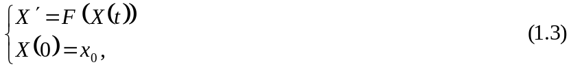
Where  A point 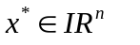is said to be an equilibrium point (or stationary point or critical point) of (1.3) if
Dynamical System: A dynamical system may be regarded as a process which is changing in time. Examples of dynamical system includes the spread of an epidemic, the motion of the stars in heavens, chemical reactions, variations in the stock market, population growth etc. Mathematically, the study of dynamical system involves deriving mathematical models of such time – dependent processes and then using the models to predict future behaviour [46]. These models often take the form of a differential equation or a difference equation. A dynamical system is made up of two parts: a state vector which exactly describes the state of the system at any given time, and a function which maps the state at one instant of time to the state at a later time. A more precise definition of a dynamical system is given as follows:
Let X represents some state space and Let 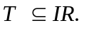A function
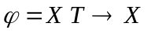that satisfies the two properties

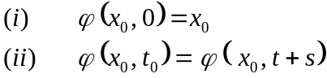
is called a dynamical system on X.
Epidemic: This is a disease temporarily prevalent in a community or throughout a large area. That is, affecting many in a community at once.
Endemic: This is the constant presence of a disease or infectious agent within a given geographical area. It may also refer to the usual prevalence of a given disease in the population without the need for external inputs. That is, each person who becomes infected with the disease must pass it on to one other person on average.
Pandemic: An epidemic of infectious disease that has spread through human population across a large region is called pandemic; for instance, multiple continents, or even worldwide.
Susceptible: A person or animal not possessing sufficient resistance against a particular pathogenic agent to prevent contracting infection or disease when exposed to the agent.
Infected: A person or animal that harbors an infectious agent and who has either manifest disease or in apparent infection (i.e., carrier).
Reproductive Number: This is the expected number of secondary infections that result from introducing a single infected individual into an otherwise susceptible population. It is denoted as R₀. The metric is useful because it helps determine whether or not an infectious disease can spread through a population. When R₀<1, the infection will die out in the long run. But if R₀>1, the infection will be able to spread in a population.
Spectral Radius: In mathematics, the spectral radius of a square matrix or a bounded linear operator is the supremum among the absolute values of the elements in its spectrum, which is sometimes denoted by 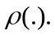that is the spectral radius of a real matrix A is defined by
In other words, the spectral radius measures the largest magnitude attained by any eigenvalue.
Mathematical Modeling
Mathematical model is a simplified representative of certain aspects of a real system, created using mathematical concept such as functions, graphs, diagrams and equations to solve problems in the real world [42]. Other definitions of mathematical modeling have also been given by various authors. For instance, Neumaier A defined mathematical modeling as the art of translating physical problems into tractable mathematical formulations whose theoretical and numerical analysis provides understanding of the real life phenomenon and solution to the problem. Modeling involves identifying and selecting relevant features symbolically, analyzing and reasoning about the model and characteristics of the situation, and considering the accuracy and limitations of the model.
A mathematical model can be formulated either through intuitive reasoning about the Phenomenon or from physical law based on evidence from experiment. It is usually constructed in the language of mathematics, logic, and computer following the algebraic rules of syntax. A mathematical model often takes the form of differential equation or system of differential equations. Since our goal is to use the equation to solve specific problems, we are interested in specific rather than general solutions. We obtain this specific solutions by imposing on the equation some initial and boundary conditions. Generally, the success of a model depends on how easily it can be used and how accurate are its predictions. The use of computers has extended modeling by allowing combination of data, interaction, repetition, sound graphics, and other displays for various types of mathematical modeling. However, models usually have a limited range of validity and should not be applied outside this range. According to Aris R a mathematical model is a set of equations, which are the mathematical translation of hypothesis (or assumptions) when interpreting model prediction. It is thus important to bear in mind the underlying assumptions. An assumption, by our definition is an unverified proposition, tentatively accepted to explain certain facts or to provide a basis for further investigation.
Modeling has been applied in virtually every sphere of man’s existence and it is as wide as nature itself. The list is not exhaustible. Modeling has been used to solve problems of robotics in the area of Artificial intelligence; detection of planetary systems in Astronomy; population dynamics and spread of infectious disease in Biology; planning of production units in Chemical Engineering; stability of electric circuits, microchip analysis and power supply network optimization in Electric Engineering; prediction of oil or ore deposits and earthquake in Geosciences; stability of structures and structural optimization in Civil Engineering; and so on. There is hardly any problem that cannot be modeled mathematically if one is versed in modeling. Thus, our goal/aim is to use mathematical modeling in studying dynamics and control spread of cholera epidemics, in order to understand the cholera dynamics better and to predict the occurrence of some hazards so that effective preventive measures can be taken.

CHAPTER TWO

LITERATURE REVIEW
In this chapter, we give a brief survey on the previous works pertaining to the proposed study.

2.1 Review of Mathematical Models
Mathematical models play a great role in the development of epidemiological theories. They help to synthesize the current empirical knowledge about the disease, to infer cause-effect relationships and to suggest experimental design to test alternative hypotheses. A lot of surveillance in cholera dynamics had been published, significantly of interest are the mathematical models formulated by Capasso and Paveri-Fontana (1979) to describe the 1973’s cholera epidemics in Italy and the Codeco model. The former was a system of two ordinary differential equations; the first considered the dynamics of the infected at time t and the second that of the toxigenic V. cholera in aquatic reservoir. Such a model is only capable of short term study of the disease dynamics, since it does not include the interaction of the susceptible population which plays a significant role in studying the disease for a long time. Hence the later extended Capasso’s model to a system of three ordinary differential equations with the susceptible dynamics included making it capable of capturing a long term study of the disease dynamics. However these models compel the net growth rate to always be negative by taking loss rate be greater than the production rate. This is not always true for the bacteria population, though the bacteria do not maintain a stable population in the aquatic environment. But if the loss rate is perpetually greater than its production rate, then as t tend to infinity the bacteria population will eventually reduce to an asymptotic size and there will not be a threat (epidemic). Hence, a model that allows a positive growth rate should be appropriate.
Aparicio and Pascual studied an implicit treatment of transmission in networks by building epidemiological models from the basic reproductive number of the disease, R₀. They showed that it is possible to incorporate the important effects of network structure on disease spread with a mean-field model derived from individual level considerations. They proposed that the fundamental number R₀, which is typically derived as a threshold quantity, be used instead as a central parameter to construct the model from. They also showed that reliable estimates of individual level parameters can replace a detailed knowledge of network structure, which in general may be difficult to obtain.
In a further study on the space-time evolution of a cholera epidemic, Bertuzzo, et al studied how river networks, acting as environmental corridors for pathogens, affect the spreading of cholera dynamics. Specifically, they compared epidemiological data from the real world with the space-time evolution of infected individuals predicted by a theoretical scheme based on reactive transport of infective agents through a biased network portraying actual river pathways. They argued that the theoretical scheme is remarkably capable of predicting actual outbreaks and, indeed that network structures play a controlling role in the actual, rather anisotropic propagation of infections, in analogy to spreading of species or to migration processes that also use rivers as ecological corridors.
In a study on serotype cycles in cholera dynamics, Koelle, et al investigated whether patterns in cholera’s serotype fluctuations provided quantitative empirical evidence for theoretically expected strain-cycling behaviour. Their mathematical model was able to capture the observed cyclical serotype dynamics seen in the cholera data when all four demographic and epidemiological data or had reasonable ranges independently estimated R₀. Combined with the reconstructed effective reproductive rates, their analysis indicated that liquid, but incomplete, cross-immunity between cholera’s serotype is a well-supported explanation for the observed long-time changes in serotype dominance. This research provides insight into the reason for serotype dominance changes; it also helps us understand how epidemiological factors, such as R₀ and the degree of cross-immunity affect the period of these serotype cycles.
Hartley et al proposed an epidemiological model for the dynamics of cholera that explicitly incorporates a hyper infectious stage of the pathogen vibrio cholerae, following laboratory findings that passage of the bacterium through the gastrointestinal tract result in a short-lived more highly infectious state. The article provided deeper insight into cholera epidemics, though no rigorous dynamical analysis was presented in that work with its focus on medical aspects. Their model differing from most epidemiological models is a combination of a SIR formulation and two environmental variables, which lead to a combined human-environmental epidemiological model and constitute a high-dimensional autonomous system.
Ashleigh et al studied cholera epidemic in Haiti by using a transmission model to explain spatial transmission of disease and identify optimal control interventions. Their objective was to predict, by using a mathematical model, the sequence and timing of regional cholera epidemic in Haiti and explore the potential effects of disease – control strategies. Their result revealed the plausible range for cholera’s basic reproductive number R₀, defined as the number of secondary cases per primary case in a susceptible population without intervention, was 2.06 to 2.78. The order and timing of regional cholera outbreaks, predicted by the gravity model, were closely correlated with empirical observations. Analysis of changes in disease dynamics overtime suggests that public health interventions have substantially affected this epidemic. A limited vaccine supply provided late in the epidemic was projected to have a modest effect.
Bayleyen Y.N studied mathematical analysis of a model of cholera transmission dynamics. He proposed a new mathematical model for cholera transmission dynamics and he rigorously analyzed the model. In his essay, historical pandemics of the disease, transmission means, global impact of the disease and control mechanisms of cholera disease were briefly discussed. Since the survival rate of the Vibrio cholerae is often a function of time delay, he incorporated a time delay in the V. cholerae population and found a threshold condition in terms of the parameters of the model. He also discussed possible stability switch based on the theorem of stability switch. In his result, it is shown that the disease free equilibrium is locally and globally stable for no time delay. Furthermore, for the case with time delay, it is shown that a disease free equilibrium is globally asymptotically stable if R₀<1, and the model has an endemic equilibrium where R₀>1.
Liao and Wang conducted a dynamical analysis of the deterministic cholera model proposed by Harley et al. They studied the stability of both the disease-free and endemic equilibria so as to explore the complex epidemic and endemic dynamics of the disease. They demonstrated a real-world application of the model by investigating the recent cholera outbreak in Zimbabwe. Also, they presented numerical simulation results to verify the analytical predictions. The stability analysis based on Codeco’s model predictions indicates that if the number of susceptible in this population is greater than a critical number S_{c}, an outbreak will occur. Also, that endemism in sanitized communities requires a permanent reservoir while endemism in poor communities requires just transient reservoirs and a sufficiently high turnover of susceptible. Other models focused on the environmental factors associated with cholera epidemic. Although control measures in the spread of infection is not in itself a new idea in epidemic models (see for instance, Ashleigh et al (2010). cholera epidemic in Haiti: using a transmission model to explain spatial spread of disease and identify optimal control interventions), to the best of our knowledge, no such model has been proposed for the case of cholera. Since mathematical models on the effect of control measure in the spread of cholera are lacking, it is therefore the intention of this study to formulate and analyze a new mathematical model that incorporates control measures such as vaccination, provision of clean water and treatment respectively into the model, in an effort to understand and assess the effects.

2.1 SIBR Model
Mathematical epidemiological models have become a powerful tool in analyzing the spread and control of infectious diseases. In this section he used mathematical model to understand the dynamics of cholera epidemics. He consider a model proposed by Codeco C.T for epidemic and endemic dynamics of cholera in aquatic reservoir. He perform a dynamical system analysis of the model so as to explore the effect of contaminated water in the dynamics of cholera. The model proposed by Codeco C.T is given as follows:

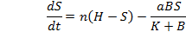

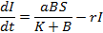 (2.0)

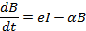

See Tables 2.1 and 2.2 for the meaning of variables and parameters. A schematic diagram of the model is given below in figure 2.1.

2.2 Model Formulation Based on SIBR Model
The cholera model classifies the human population at time t, into disjoint compartments S(t), I(t), R(t) and B(t). Therefore we will use the SIBR model to describe a disease with temporary immunity on recovery from the infection.  is the recruitment rate into the susceptible class, which could include immigrants and /or newborns that are uninfected, andis the natural death rate. The pathogen is degenerated at a rate 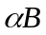 and its growth is enhanced by the cholera infected individuals at a constant rate e, which is a measure of the contribution of each infected individual to the population of V. Cholerae in the aquatic environment. The susceptible individuals acquire cholera infection following contact with the pathogen population at a rate λ, where after they are exposed to contaminated water at the rate, whose pathogen concentration is k.
Table 2.1: State variables of the model
Symbol | Description
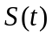 | Susceptible human population at time t
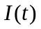 | Infected human population at time t
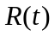 | Recovered human population at time t
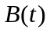 | The pathogen population at time t

Table 2.2: Model parameters and their descriptions
Symbol | Description
 | Recruitment rate
 | Exposure rate to contaminated water
 | Concentration of V. Cholera in water
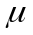 | Per capita natural death rate for humans
n | Rate of loss of immunity
 | Contribution of the infected individual to the population of V. Cholerae
 | Natural recovery rate
α | Death rate of V. Cholerae in aquatic environment
 | Force of infection for susceptible

MODEL DIAGRAM
S
I
R
B

µ

Fig. 2.1: Schematic representation of the model

Putting the formulation and the assumptions together gives the following system of differential equations:

(2.1)

The Disease-free Equilibrium point, E₀
Disease-free equilibrium points (DFE) are steady-state solutions where there is no disease. Hence, in absence of infection we have I* = 0, R* = 0 and B* = 0, which reduced (2.1) to
Therefore, the disease-free equilibrium point, E₀ is thus

2.1.1. Basic Reproduction Number: The basic reproduction number R₀ is defined as the expected number of secondary infections that result from introducing a single infected individual into an otherwise susceptible population. Here we use the second generation matrix approach to compute the basic reproduction number. According to Van den Driessche and Mangtani P the basic reproduction number R₀ near the DFE is defined as
where FV⁻¹ is the second generation matrix at DFE and 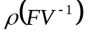denotes the spectral radius of matrix FV⁻¹. The (i, j) entry of F is the rate at which infected individuals in compartment j produce new infections in compartment i. The (j, k) entry of V⁻¹ is the average duration of stay in compartment j starting from k. From system (2.1) we observe that only the second and third equation are the infected compartments, then linearizing the infected compartment about DFE gives.

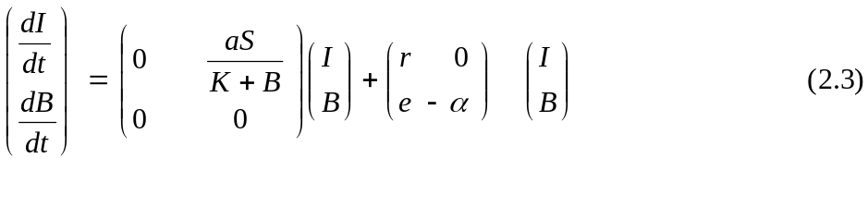
where 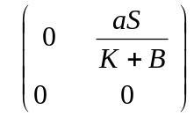 = F is the matrix of infection rate and 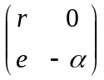 = V is the matrix of transmission rate. The spectral radius of FV⁻¹ is given as . That is,
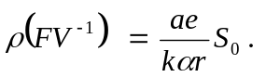(See [46] for details).
Therefore we conclude that the basic reproduction number R₀ of the system (2.1) is 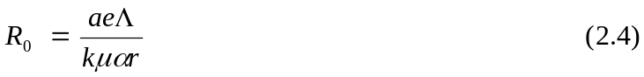
2.1.2 Stability Analysis of Disease – Free Equilibrium (DFE): He analyze the stability of the DFE. The Jacobian matrix of model (2.1) evaluated at DFE (H,0,0) is

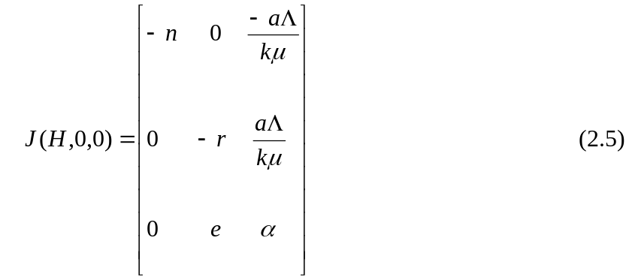

The characteristic equation of J (H, 0, 0) is
where
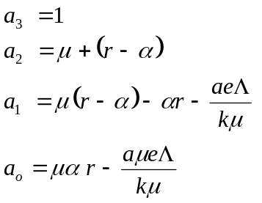
Using the Routh–Hurwitz Criterion for stability, he need to show that 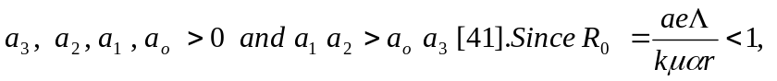implies that
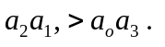
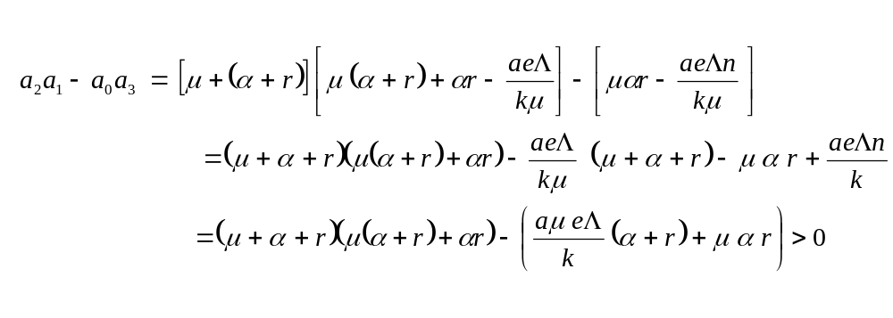
Hence the disease –free equilibrium 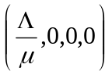of system (2.1) is locally asymptotically stable wherever R₀ < 1. This implies that a small number of infected individual into the population will not lead to an epidemic provided R₀< 1.

The Endemic Equilibrium Point E₁
Endemic equilibrium point E₁ is a steady-state solution, where the disease persists in the population. At endemic state, everybody has the disease, i.e.
S* = R* = 0.
2.1.3 Stability analysis of endemic equilibrium (EE): Here he determine the endemic equilibrium (E₁) of system (2.1). Firstly, we determine the EE E₁ = (0, I*, B*, 0) of the system (2.1) by setting
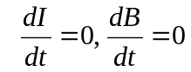 and solve for I and B. From the third equation in system (2.1) we have 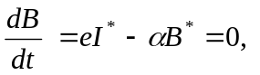which implies that and
Hence system (2.1) has an endemic equilibrium given by E₁ = ().

2.1.4. Theorem (Local stability of endemic equilibrium): The endemic equilibrium (E₁) of system (2.1) is locally asymptotically stable whenever R₀ > 1.

Proof
The Jacobian Matrix of system (2.1) evaluated at (E₁) is
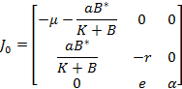
To make the algebraic manipulation simpler, we set
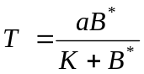
The Jacobian Matrix then becomes
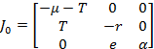 (2.8)

The characteristic equation of 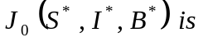
where
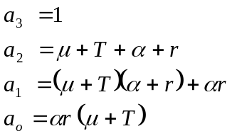
Clearly, 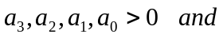
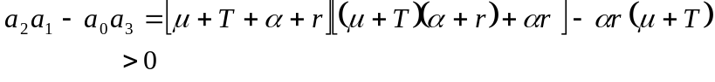
Therefore, by the Routh-Hurwitz criterion for stability, we conclude that the E₁ is locally asymptotically stable whenever R₀>1.
2.1.5. Global stability: To ensure disease elimination is independent of the initial size of the sub-population of the model (2.1), he show that the DFE is globally asymptotically stable.

2.1.6 Theorem (Global Stability of DFE): The disease-free equilibrium (DFE) of system (2.1) is globally asymptotically stable if R₀<1.

Proof
To study the global asymptotic stability of the DFE, one common approach is to construct an appropriate Lyapunov function. We have found, however, that it is simpler to apply the following result introduced by Castillo-Chavez.
Lemma: Castillo-Chavez consider a model system written in the form
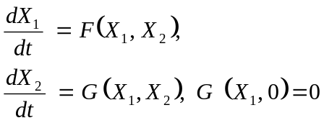
where X₁∈R^{m} denotes (its components) the number of uninfected individuals and X₂∈ R^{n} denotes (its components) the number of infected individuals including latent, infectious, etc; 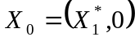 denotes the disease-free equilibrium of the system.
Also assume the condition (H₁) and (H₂) below:
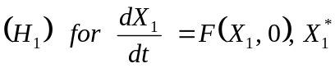 is globally asymptotically stable;
^
^
where the jacobian 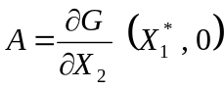 is an M-matrix (the off diagonal elements of A are nonnegative) and Ω is the region where the model makes biological sense. Then the DFE 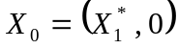 is globally asymptotically stable provided that R₀ <1.
We only need to show that the condition (H₁) and (H₂) hold when R₀ < 1. In the system (2.1), x₁ = (S, R), x₂ = (I, B) and 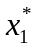= (H, 0). We note that the system 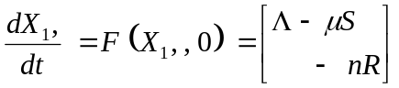
is linear and its solution can be easily found as to study the…. regardless of the values of 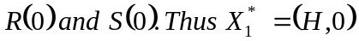 is globally asymptotically stable. Next, we have
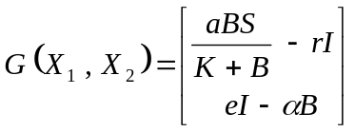
^
we obtain 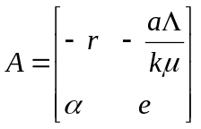 which is clearly an M-matrix. Meanwhile,
we find 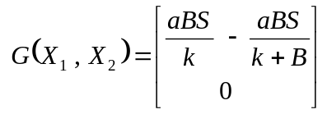
^
Since Therefore, we conclude that DFE is globally asymptotically stable whenever R₀ <1.

Theorem 2.1.6 guarantees that the solutions of the model (2.1) always converges to the DFE, whenever R₀<1. Epidemiologically, it means that the disease will be eliminated from the community whenever R₀ <1.
2.1.7 Theorem (Global Stability of EE): The endemic equilibrium is globally asymptotically stable if R₀ > 1.
Proof
When the incidence rates become non-linear, system (2.1) generally has dimensions higher than two. For several special types of cholera models with non-linear incidence rates, the global endemic stability was analyzed in detail in a recent work (Liao, Sand Wang, J (2011). Stability analysis and application of a Mathematical cholera model). These linear and non-linear results motivate the conjecture that endemic equilibrium of system (2.1) is globally asymptotically stable in general (provided R₀ > 1). The epidemiological implication of this is that the disease (cholera) will remain endemic in the community whenever R₀ > 1.
CHAPTER THREE
CONTROL MODELS FOR CHOLERA EPIDEMICS
As said in the previous chapter, cholera is one of the water – borne disease which is transmitted by drinking contaminated water or eating contaminated food. The spread of this disease can be reduced by providing control measures like, the provision of clean water, vaccination and treatment. In this section we explore the effect of these control measures by introducing each of them into the modified (SIBR) model and performing dynamical system analysis of the new models.
3.1 Vaccination Model
One of the methods of controlling the spread of the cholera epidemic is by vaccination of susceptible individuals in the community. Here, we assume the vaccine is imperfect is i.e., 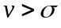 this means that vaccinated individuals will not have 100% immunity against cholera. Introducing this vaccine into the model moves people from susceptible compartment to recovered compartment, hence the model becomes. 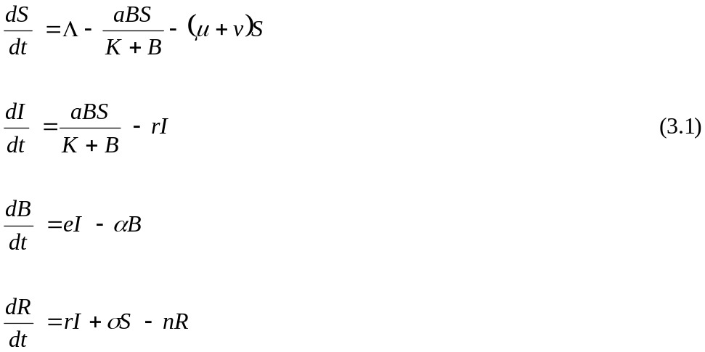
Where is the rate of vaccination and is the rate of recovered susceptible. The system (3.1) has a disease free equilibrium given by
3.1.1 Basic Reproduction number
We compute the basic reproduction number of model (3.1) using the next generation matrix approach. Line arising the infective compartments of model (3.1) at the disease – free equilibrium, we have

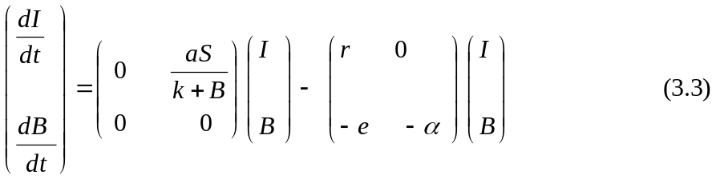

where 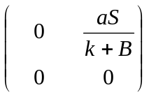 = F is the matrix of infection rate and
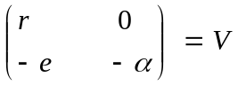 is the matrix of transmission rate. The Spectral radius of 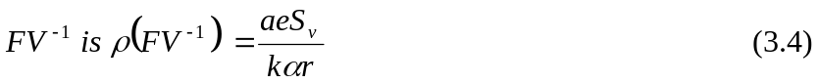
Therefore, the basic reproduction number 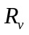of system (3.1) is

3.1.2 Stability analysis of disease – free equilibrium (DFE): We analyze the local stability of diseases – free equilibrium (3.2) by showing that the characteristics equation of the Jacobian matrix of system (3.1) evaluated at DFE satisfies the Routh–Hurwitz criterion for stability.
3.1.3. Theorem (Local Stability of DFE): The disease – free equilibrium (3.2) of system (3.1) is locally asymptotically stable whenever < 1.
Proof
The Jacobian matrix of system (3.1) evaluated at DFE (3.2) is
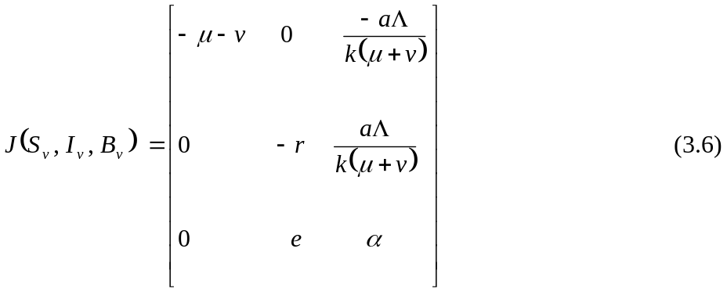
The characteristics equation of 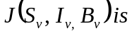
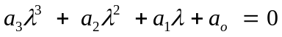
Where 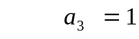
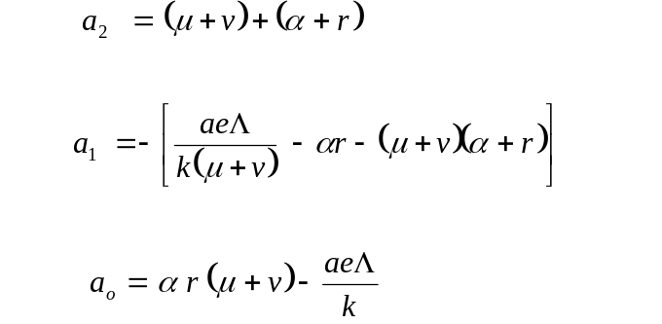

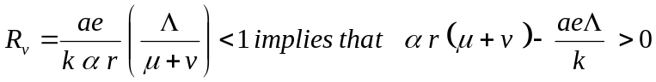
Thus we have that 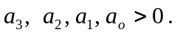It remains to show that 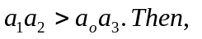
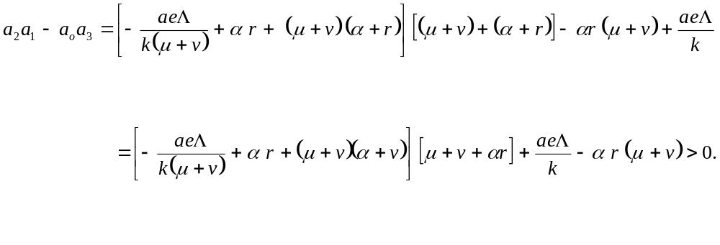Therefore by the Routh-Hurwitz criterion for stability, we conclude that the DFE is locally asymptotically stable whenever R_{v} < 1.
3.1.4. Endemic Equilibrium: Endemic equilibrium 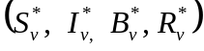 exists for system (3.1). We compute it by setting 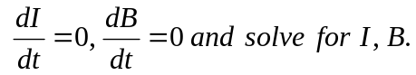 Therefore the endemic equilibrium of system (3.1) is E₂ = ().
3.1.5 Theorem (Local stability of endemic equilibrium): The endemic equilibrium (E₂) of system (3.1) is locally asymptotically stable whenever 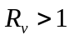
Proof
The Jacobian Matrix of system (3.1) evaluated at (E₂)
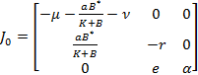
To make the algebraic manipulation simpler, we set
The Jacobian Matrix then becomes
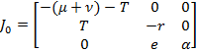 (3.9)
The characteristics equation of 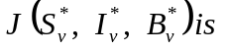
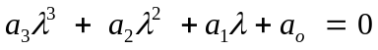 (3.10)
where,
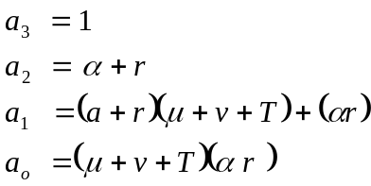
Clearly
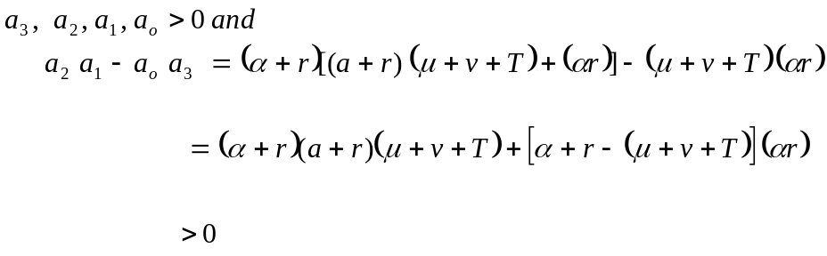
Therefore, by the Routh-Hurwitz criterion for stability, we conclude that the EE is locally asymptotically stable whenever.
3.1.6 Epidemiological Implication: Here we compare some of the results we obtained with the results of the previous model in order to see the effect of introducing vaccination into the model. Based on these results, we have the following:
* The basic reproduction number when the vaccination is introduced into the model is less than the basic reproduction number R₀, when there is no vaccination in the model. That is,
The epidemiological meaning of this is that the rate of spread of the cholera epidemic will be higher when there is no vaccination than when vaccination is introduced in the community. Hence, vaccinating susceptible individuals reduces the rate of spread of the cholera epidemic.
* Endemic equilibrium (EE) exists when a vaccination is introduced in the model. This means that introducing a vaccination does not guarantee total elimination of cholera in a community; rather it reduces the number of infected individuals.
This shows that at EE, the number of infected individuals when a vaccine is introduced is less than the number of infected individuals when there is no vaccine.
3.2 Provision of Clean Water model
In this section we replace vaccination with the provision of clean water and perform a dynamical system analysis of the new model to see the effect of this in the model. Here, clean water would mean water free from bacteria. We assume that provision of clean water decreases the concentration of pathogens in water reservoir at a rate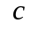, and that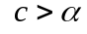, since according to Musekwa, V. cholerae population decay does not necessarily imply death but can also mean a transition towards a non-culturable state.

As a result of this, we obtain the modified system:
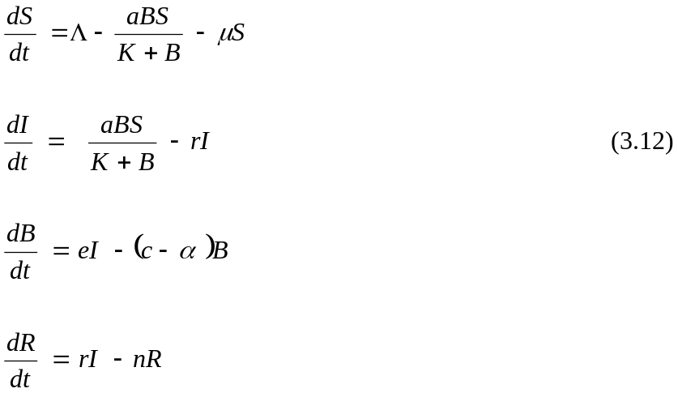
where is the rate of provision of clean water. System (3.12) has a disease – free equilibrium given by

3.2.1. Basic reproduction number: The basic reproduction number 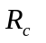of model (3.13), using the next generation matrix approach is given by

3.2.1. Theorem (Local stability of DFE): The disease – free equilibrium (DFE) of system (3.12) is locally asymptotically stable whenever 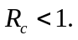

Proof
The Jacobian matrix of system (3.12) evaluated at DFE (3.13) is

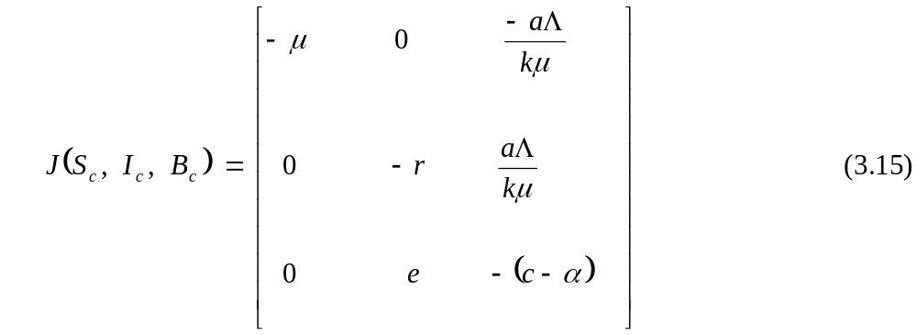
The characteristics system of 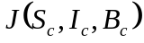 is
Where
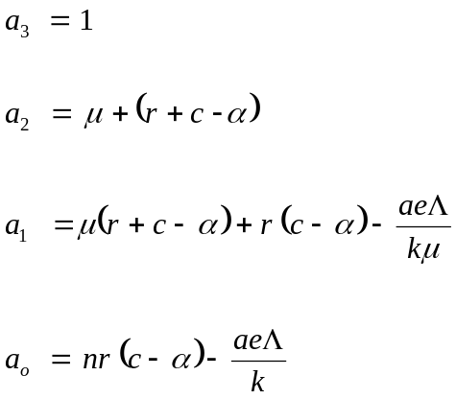
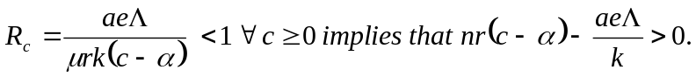 Thus we have that
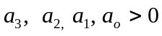. It remains to show that 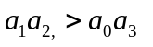
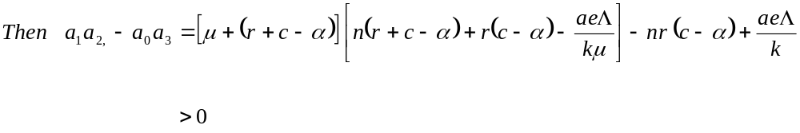
So that by the Routh-Hurwitz criterion for stability, we have that the disease – free equilibrium is locally asymptotically stable whenever

3.2.3 Endemic equilibrium 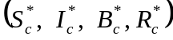 exists for model (3.12): We compute the endemic equilibrium using a similar approach as in the case of the vaccination model and obtain

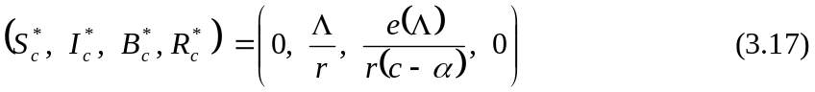
3.2.4 Theorem (Local stability of endemic equilibrium). The endemic equilibrium (EE) of system (3.12) is locally asymptotically stable whenever R_{c} > 1.

Proof
The Jacobian matrix of system (3.12) evaluated at EE (3.17) is

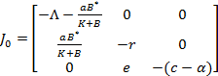
To make the algebraic manipulation simpler, we set
The Jacobian Matrix then becomes
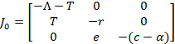
The characteristic equation of 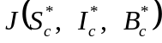 is as follows:
where
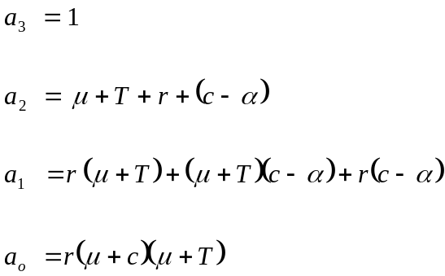

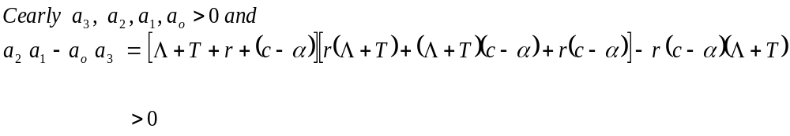
Therefore, by the Routh-Hurwitz criterion for stability, we conclude that the endemic equilibrium (3.17) is locally asymptotically stable whenever R_{c} >1.
3.2.5. Epidemiological Implication: As in the case of the vaccination model (3.1), we are going to compare our results with results obtained in the previous model in order to see the effect of introducing clean water into the model. Based on our findings on the dynamical system analysis of the provision of clean water model, we have that
* The basic reproduction number 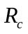 satisfies the following inequality:
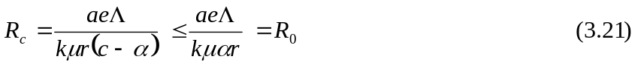
This means that the rate of spread of the cholera epidemic will be higher when water is contaminated than when clean water is provided in a community. Therefore, provision of clean water reduces the rate of spread of the cholera epidemic.
* Endemic equilibrium exists when clean water is introduced into the model. This means that introducing clean water does not guarantee total elimination of cholera in a community; rather it reduces the number of infected individuals.
This shows that at EE, the number of infected individuals when clean water is introduced is less than the number of infected individuals when the water is contaminated.
3.3 Treatment Model
We have introduced a vaccination and clean water and have shown that it reduces the number of susceptible, and the rate at which susceptible people contact cholera, respectively. What about those already infected by cholera? We are made to understand that if people with cholera are treated quickly and properly, the mortality rate is less than 1%. However, if they are left untreated, the mortality rate rises to 50 – 60%. Therefore it is very important that we consider introducing treatment into the model. We introduce treatment thereby moving people from infective compartment to recovered compartment. We assume that the treatment is imperfect but does not affect the individual’s immune system. So once an individual is treated, he/she moves to the recovered compartment, at the rate 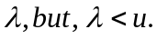 Therefore, the model for treatment becomes
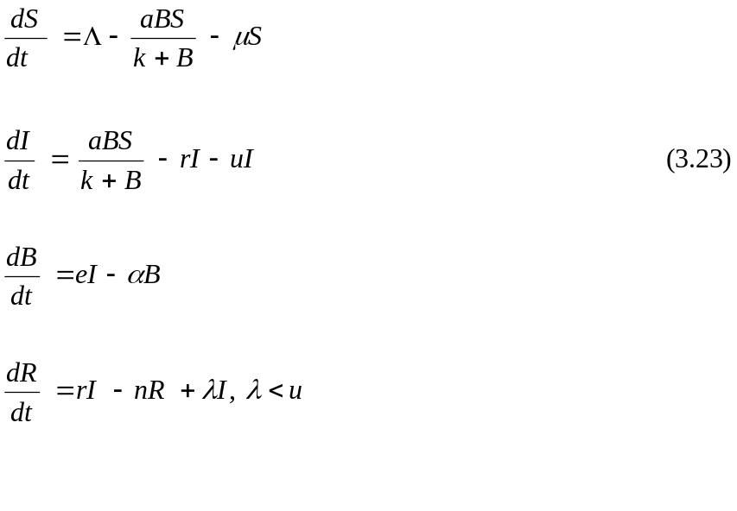
Where is the rate at which infected individuals are being treated and is the rate at which infected people are recovered. The disease – free equilibrium of the treatment model (3.23) is given by
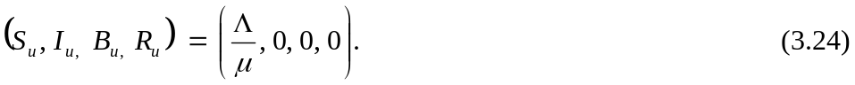
3.3.1. Basic reproduction number: The basic reproduction number of the treatment model (3.23) is given by
3.3.2. Theorem (Local Stability of DFE): The disease – free equilibrium (3.24) of system is locally asymptotically stable whenever 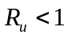

Proof
The Jacobian matrix of system (2.23) evaluated at DFE (3.24) is

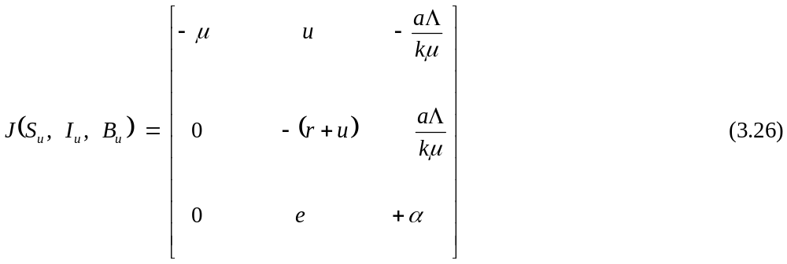
The characteristic equation of 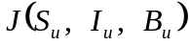 is

where
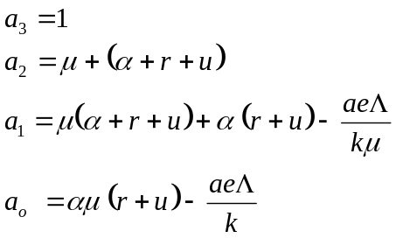
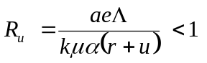implies that 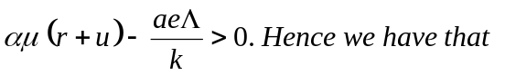
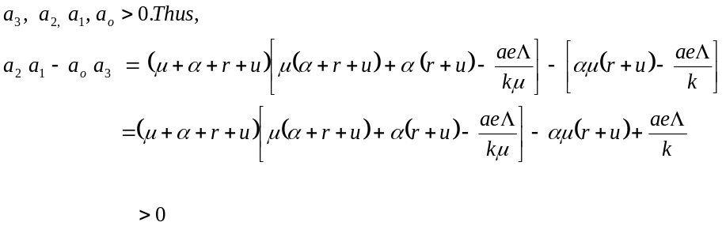
Therefore, by the Routh-Hurwitz criterion for stability, we conclude that the disease – free equilibrium (3.24) is locally asymptotically stable whenever

3.3.3. Endemic equilibrium: The endemic equilibrium of the treatment model (3.23) is given by
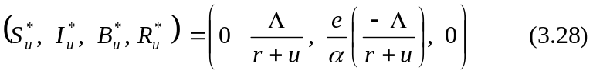
3.3.4 Theorem (Local stability of EE): The endemic equilibrium (3.28) of system (3.23) is locally asymptotically stable whenever
Proof
The Jacobian matrix of system (3.23) evaluated at EE (3.28) is
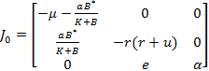
To make the algebraic manipulation simpler, we set
The Jacobian Matrix then becomes
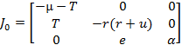

The characteristics equation of 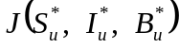 is

where
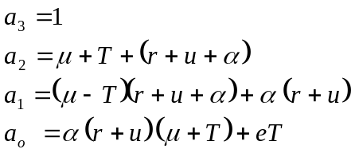
Clearly 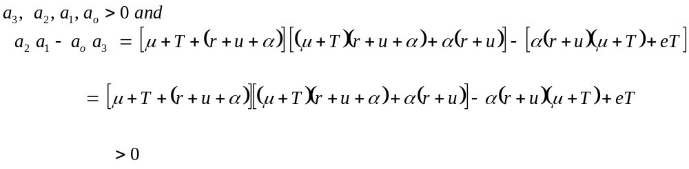
Therefore, by the Routh-Hurwitz criterion for stability, we conclude that the endemic equilibrium (3.28) is locally asymptotically stable whenever.
3.3.5 Epidemiological implication: From the result, we observed that:
* The basic reproduction number 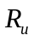 when treatment is introduced into the model is less than the basic reproduction number R₀, when there is no treatment in the model. That is, 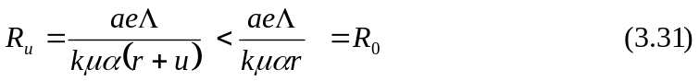
This means that the rate of the spread of cholera epidemic is less when the infected individual is being treated properly than when he/she is left untreated.
* We also observed that an endemic equilibrium (EE) exists when treatment is introduced into the model. This means that introducing treatment does not guarantee total elimination of the cholera epidemic; rather it reduces the number of infected individuals. Therefore we conclude that introducing treatment reduces the number of infective thereby reducing the chances of an epidemic.
3.4 Combined Control Measure Model
In the last three sections, we saw that introducing vaccination, provision of clean water or treatment reduces the rate of the spread of cholera. In this section, we consider introducing the three control measures simultaneously into the model. We note that vaccination of susceptible individuals, provision of clean water and treatment of infected individuals are independent control measures, and hence we can introduce the three simultaneously into the model. We use the same assumption as in the case of vaccination, provision of clean water and treatment, then the new model becomes
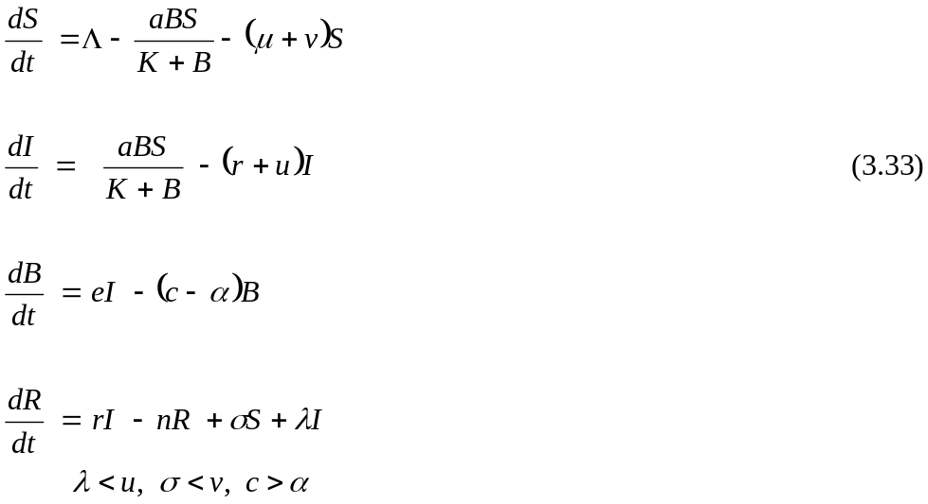
Disease – free equilibrium exists for model (3.33) and is given by
3.4.1. Basic reproduction number: We compute the basic reproduction number 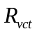 of model (3.33) using the next generation matrix approach as in the case of the vaccination model and obtain
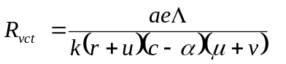 (3.35)
3.4.2. Theorem (Local Stability of DFE): The disease – free equilibrium (3.34) of system (3.33) is locally asymptotically stable whenever R_{vct} < 1.

Proof
The Jacobian Matrix of system (3.33) evaluated at DFE (3.34) is
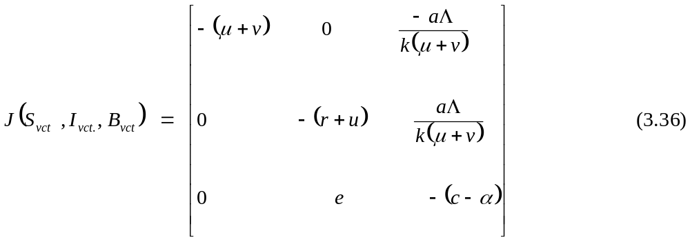
The characteristic equation of 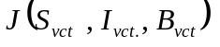is
where
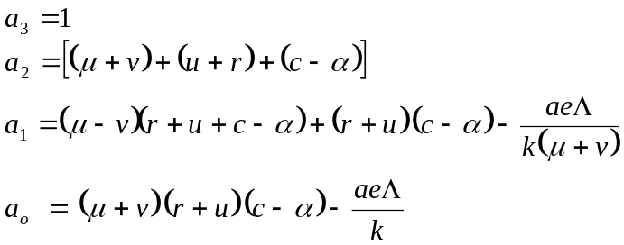
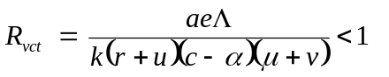implies that 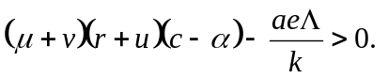
Hence, we have that
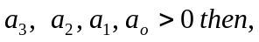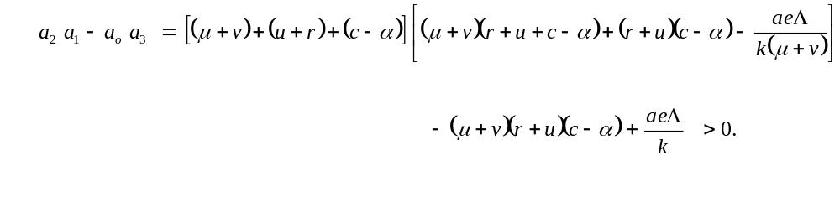
Therefore, by the Routh-Hurwitz criterion for stability, we have that the disease – free equilibrium (3.34) is locally asymptotically stable whenever 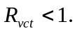
3.4.3. Endemic equilibrium: The endemic equilibrium 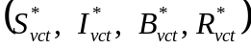 of model (3.33) is given by
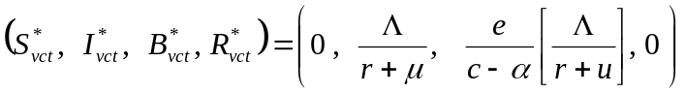 (3.38)
3.4.4. Theorem (Local stability of EE): The endemic equilibrium (3.38) of system (3.33) is locally asymptotically stable whenever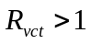.
Proof
The Jacobian matrix of system (3.33) evaluated at EE (3.38) is

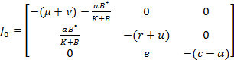

To make the algebraic manipulation simpler, we set
The Jacobian Matrix then becomes
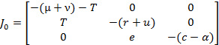

The characteristic equation of 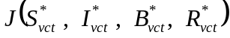 is
where,
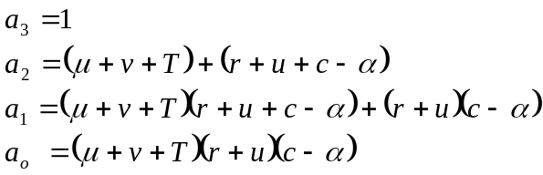
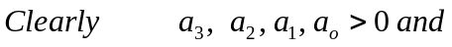
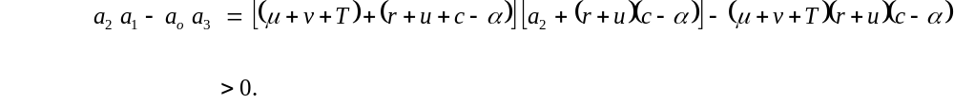Therefore, by the Routh-Hurwitz criterion for stability, we conclude that the endemic equilibrium (3.38) is locally asymptotically stable whenever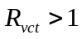.
3.4.5. Epidemiological implication: In this section, we investigate the effect of combined control measures over a single control measure in the model. Based on the analysis, we observed the following:
* The basic reproduction number when we introduce the three control measures in the model is less than the Basic reproduction numbers 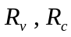and when only one of the control measures is introduced in the model.
That is,
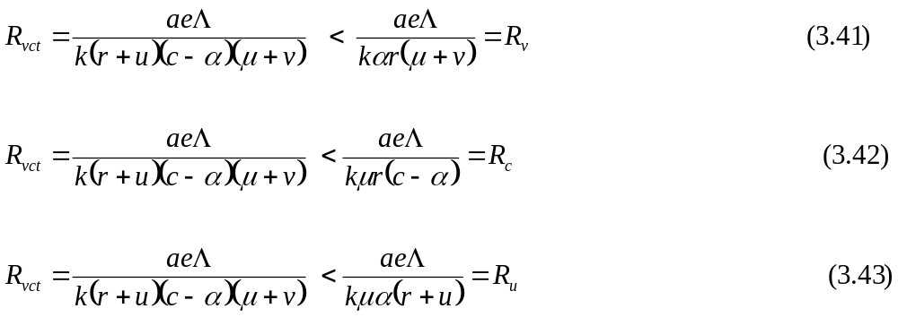
This means that the rate of the spread of cholera epidemic is less when the three control measures are introduced than when only one of the control measures is introduced.
* Endemic equilibrium (EE) exists when the three control measures are introduced into the model. This means that introducing the three control measure does not guarantee total elimination of cholera epidemic; rather it reduces the number of infected individuals. This means that at EE, the number of infected individuals, when the three control measures are introduced is less than the number of infected individuals, when only one of the control measures is introduced. Based on the analysis, we conclude that introducing the combined control measures reduces the spread of cholera better than when only one control measures is introduced.

3.4b. Combined clean water & treatment model
Having considered the combined control measures, i.e., introducing the three control measures simultaneously into the SIBR model, we can now consider introducing only two control measure such as; provision of clean water and treatment simultaneously into the SIBR model.
This is because, vaccination is provided by the Government which may not be certain or equally distributed. The affected community will be able to provide the clean water and treatment facilities. Here, we assume the same assumptions as in the previous cases.

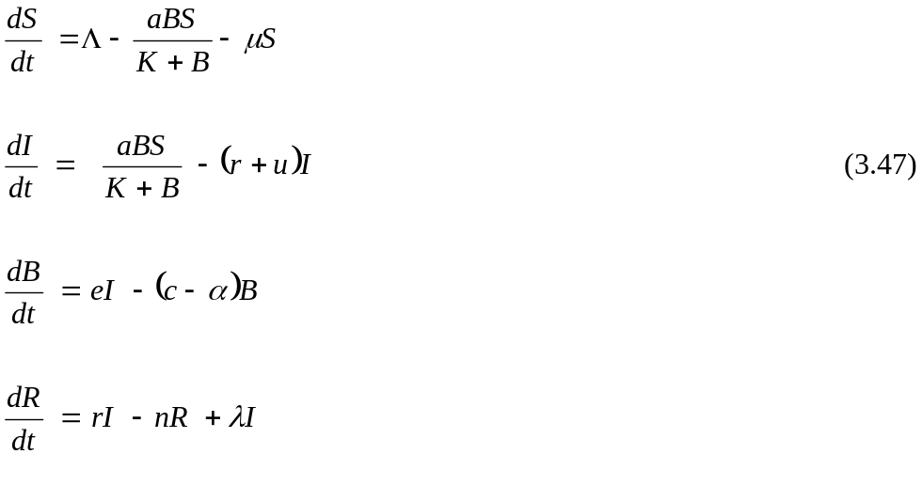
The basic reproduction number is obtained as:
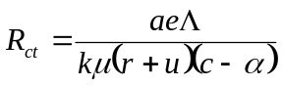
Epidemiological Implication: The basic reproduction number when compared to the basic reproduction numbers when only one of the control measures is introduced into the model is lesser, but greater than the R_{vct}. Also, it reduces the number of infected individuals better than when only one control measures in introduced. However, combined control measures (with the three measures) control better than when any two is combined.

3.5 Global Stability of the Combined Control Model
In this section, we shall investigate the global asymptotic stability of the combined control model at both the disease-free-equilibrium and the endemic equilibrium. We shall apply the result introduced by Castillo-Chavez et al to achieve this.

3.5.1. Theorem (Global Stability at DFE): The disease free equilibrium of the model (3.33) is globally asymptotic stable if 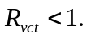
Proof
We only need to show that the conditions (H₁) and (H₂) hold when In the ODE system (3.33), X₁ = (S, R), X₂ = (I, B) and
is linear and its solution can be easily found as 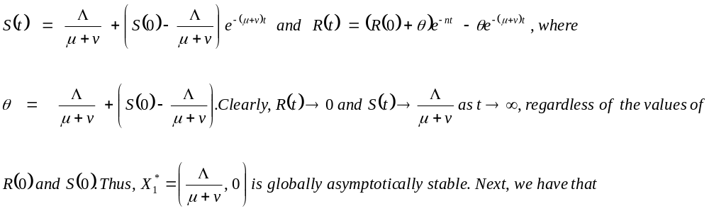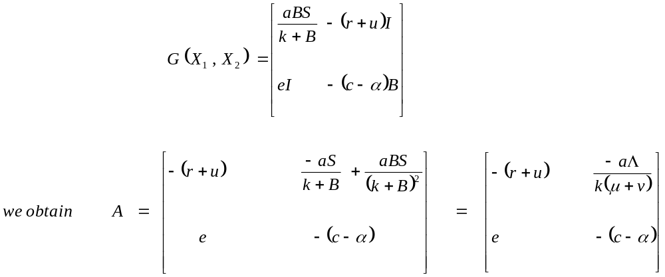
Which is clearly an M – matrix. Meanwhile, we find

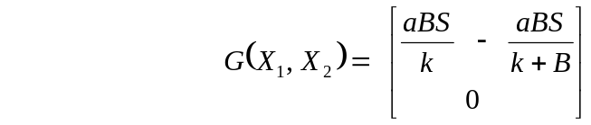
^
Since 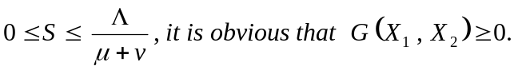Therefore, the disease free equilibrium of the model (3.33) is globally asymptotic stable if R_{vct} < 1. Details of the proof of the global stability of the endemic equilibrium (3.33) will be explored in a future study.
^

CHAPTER FOUR
NUMERICAL SIMULATIONS
Numerical simulation is a very important aspect of dynamical system analysis. We understand that the models are non-linear differential equations whose exact solutions are very difficult to determine. As a result of this we resort to numerical simulation in order to get an idea of the behaviour of the model as time progresses. In this section we shall perform a numerical simulation of the model using the MATLAB. Some of the parameter values of the model are chosen from [13].
Table 4.1 Parameter values used for Numerical simulations
Parameter | value | Parameter | Value
e | 10 |  | 0.6
 | 0.5 |  | 0.7
 | 0.533 |  | 1000000
 | 0.08 | r | 0.2
 | 0.6 | H | 1000

4.1 Explanation of Simulation
We performed a numerical simulation of the models. Here we explain the results of the simulations (see the simulation graphs). The explanation is as follows:
The numerical result in Figure (a) shows that the susceptible population with control decreases as time progresses. It illustrates that susceptible with vaccination and combined control decreases more than susceptible with no control, clean water and treatment respectively, as time progresses. Figure (b) shows the plot of infected individuals with control against time. The plot illustrates that infected population decreases with time on the introduction of treatment. On the introduction of combined treatment, the number of infected individuals declined most. Figure (c) shows the plot of pathogens population with control against time. It illustrates that introduction of control treatment decreases the concentration of pathogen in water. A combined control measure reduces the population of pathogen mostly. Figure (d) shows that introduction of combined control measures increases the number of removed individuals mostly than the single treatments. Figure (e) shows the plot of reproduction numbers verses contact rate. It illustrates that the rate of contact of cholera is less when the combined control measures are introduced than when only one of the control measures is introduced. These numerical simulation results suggest that introducing the combined control measures reduces the spread of cholera better than when only one control measure is introduced as confirmed by the dynamical system analysis.
4.2 Sensitivity Analysis
Sensitivity analysis is used to determine the relative importance of model parameters to cholera transmission and its prevalence. We perform the analysis by calculating the sensitivity indices of the basic reproduction number, R₀. According to Hartman P, sensitivity analysis is commonly used to determine the robustness of model predictions to parameter values, since there are usually errors in data collection and estimated values. We are thus interested in parameters that significantly affect the model reproduction number since these are the parameters that should be taken into consideration when considering interventions strategies. Sensitivity analysis also permits us to measure the relative changes in a state variable when a parameter changes. The normalized forward sensitivity index of a variable to a parameter is the ratio of the relative changes in the variables to the relative changes in the parameter. Since the reproduction number is a differentiable function of the parameters, the sensitivity index may alternatively be defined using partial derivatives. For instance, the computation of the sensitivity index of R_{vct} with respect to e using the parameter values in the table is given by
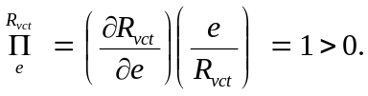
This shows that R_{vct} is an increasing function of e and the parameter e has a very great influence on the spread of cholera. Note, we perform the analysis by calculating the sensitivity indices of the basic reproduction number, R_{vct}, of the combined control model only. This is because the previous analysis shows that the combined control measures yield a better result than when only one control measure is introduced. We tabulate the indices of the remaining parameters in table 4.2.

Table 4.2 Sensitivity indices for R_{vct}
Parameter | Index | Parameter | Value
E | 1 |  | -0.8823
 | 1 |  | -0.750
 | -0.4322 |  | -0.5677
 | 0.8823 | K | -1

From Table 4.2, Parameters whose sensitivity indices have negative signs decrease the value of the reproduction number as their values increase, while those with positive signs increase the value R_{vct} as they increase. The system is most sensitive to k, e and 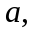 followed by μ and v. It is important to note that increasing (decreasing) k, e and by 10% decreases (increases) R_{vct} by 10%. Also, increasing (decreasing) the parameters μ and v by 10% decrease (increases) R_{vct} by 8.82%.

CHAPTER FIVE
DISCUSSION AND RECOMMENDATIONS
5.1 Discussion of results
A mathematical model for cholera epidemic incorporating control measures is presented as a system of ordinary differential equations. The diseases – free and endemic equalibra are obtained and their stabilities are investigated. The disease – free equilibrium is shown to be globally and locally asymptotically stable. The result of our analysis shows that the rate of spread of cholera will be less when there is no contaminated water than when individuals are exposed to contaminated water. We further introduce control measures (vaccination, provision of clean water and treatment) one after another into our model. The results obtained from dynamical system analysis and numerical simulations of the models shows that the introduction of control measures actually reduces the rate of the spread of cholera. We also consider the case of combined control measures whereby the three control measures are introduced simultaneously into the model. The analysis and numerical results suggest that introducing the three control measures simultaneously reduces the spread of cholera better than when only one and any two of the control measures are introduced.
Finally, we performed the sensitivity analysis by calculating the sensitivity indices of the basic reproduction number for the combined control model. The results show that the system is most sensitive to concentration of V. cholerae in water, contribution of each infected person to the population of V. cholerae in the aquatic environment and the rate of exposure to contaminated water respectively.
5.2 Observations
From our study, we observe the following:
* Introduction of control measures like vaccination of susceptible individuals, provision of clean water or treatment of infected individuals does not guarantee total elimination of cholera; rather it reduces the rate of spread.
* Introducing the three control measures simultaneously yields better results, though it still does not guarantee total elimination of cholera.
* The rate of exposure to cholera, and the concentration of the pathogen in water are most sensitive in the reproduction number.
5.3 Recommendations
Based on our study and observations, we hereby recommend the following:
- Should a cholera outbreak occurs, combined control measures are recommended.
- Since cholera is caused by drinking contaminated water or eating contaminated food, proper sanitation and disposal of sewage should be maintained and adopted respectively.
- Different sectors like the education sector, health and sanitation sector and water supply boards should work together to keep the value of R₀ < 1 because, as long as we keep R₀ < 1, there will not be a cholera outbreak in our region.

5.4 Suggestions for further work
The cholera control models and analysis proposed in this study can be extended in a number of ways. For example, climatic impacts on cholera control epidemic can be studied by incorporating seasonally variation factors into the models. Furthermore, other prevention and intervention strategies, such as hydration therapy and antibiotic treatment, can be naturally represented by modifying the models, so as to seek possible optimal control strategies.

REFERENCES

[1] Ryan, J.K and Ray, C.G. (2004). Sherris Medical Biology. McGraw-Hill. New York.

[2] Faruque, S.M and Nair, G.B. (2008). Vibrio Chlorae: Genomics and Molecular Biology. Kaiser Academic Press.

[3] http://w.w.w.ph.ucla.edu. Who first Discovered Vibrio Chlorae?

[4] Alexander, A. and Kirschner, T. (2008). Rapid Growth of Planktonic Vibro Cholera Non-OI/Non-O139 Strains in a large Alkaline Lake in Australia: Dependence on temperature and Dissolved Organic Carbon quality. Applied and Environmental Microbiology. 74:2004-2005.

[5] Joachim Reidl and Karl, E. Klose. (2008). Vibrio Cholerae and Cholera: Out of the Water and into the Host. FEMS Microbiology Reviews, 26:125-149.

[6] David, M., Hartley, J., Glem Morris Jr., and David L. Smith (2006). Hyperinfectivity: A Critical Element in the ability of V. Cholera to Cause Epidemics? Plos MEDICINE, 3:63-69.

[7] http://w.w.w.Choleraspreadproject. Cholera Spreads in river System of South Africa’s Kruger.

[8] Lacely, S.W. (1995). Clin.infect.dis Clin.Infect.Dis, 20:409.

[9] Rita, R. Colwell (1996). Global Climate and Infectious Disease: The Cholera Paradigm. Science. 274:2025-2031.

[10] http://w.w.w.textbookofbacteriology.net Vibrio Cholerae and Asiatic Cholerae and Asiatic cholera.
[11] Anderson, R.M. and May, R.M (1991). Infectious Disease of Humans. Oxford University Press.

[12] Capasso, V. and Paveri-Fontana, S.L. (1979). A Mathematical Model for the Cholera Epidemic in the European Mediterranean Region. Rev. Epidem. Sante Publ. 27:121-132.

[13] Codeco, C.T. (2001). Endemic and Epidemic Dynamics of Cholera: The Role of the Aquatic Reservoir. BMC Infect. Dis., 1:1.

[14] Aparicio, J.P and Mercedes Pascual (2007). Building Epidemiological Models from R₀: an implicit treatment of transmission in networks. Proc. R. Soc. B. 274, 505-512.

[15] Bertuzzo, E. et al, (2008). On the space-time evolution of a Cholera epidemic. WATER RESOURCES RESEARCH, Vol.44, W01424.

[16] Roberts, M.G and Heesterbeek, J.A.P. (2003). Mathematical Models in Epidemiology in encyclopedia of Life Support Systems (EOLSS), Developed under the Auspices of the UNESCO, Eolss Publishers, Oxford, UK.
[17] Koelle, K. et al, (2006). Serotype cycles in cholera Dynamics Proc. R. Soc. B. 273, 2879-2886.

[18] Britton, K.N (2003). The Essential Mathematical Biology. Springer-Verlag London.

[19] Epstein, P.R. (1993). Algal Blooms in the spread and Resistance of Cholera. Biosystems 31:209-221.

[20] Hustin, Y., Luby, S. (2008). A large Cholera Outbreak in Kano City, Nigeria, the Importance of Hand Washing with Soap and the Danger of Street Vended Water. UN’s IRIN Humanitarian Unit.

[21] Lawoyin, T.O., Ogunbode, W.A., Olumide, E.A.A. and Onadeko, M.O. (2004). Outbreak of Cholera in Ibadan, Nigeria, European Journal of Epidemiology, 15:365-368.
[22] UN Office for the Coordination of Humanitarian Affairs Integrated Regional Information Networks (IRIN) 2005.

[23] Vanguard (Lagos) July 16, 2008.

[24] Castillo-Chavez, C et al (2002). On the computation of R₀ and its role on global stability, in “Mathematical Approaches for Emerging and Reemerging Infectious Diseases: An introduction,” IMA, 125, Springer-Verlag.

[25] Dietz, K. (1993). The estimation of the basic reproduction number for infection diseases, statistical methods in Medical Research, (2):23-41.

[26] Hartman, P. (1980). Ordinary Differential Equation, John Wiley, New York.

[27] Hethcote, H.W (2000). The Mathematics of infectious diseases. SIAM Review (42): 599-65 3.

[28] Li, M.Y and Muldowney, J.S. (1995). Global Stability for the SEIR model in epidemiology. Mathematical Biosciences, (125): 155-164.

[29] Li, M.Y et al (1999). Global Dynamics of SEIR model with varying total Population size. Mathematical Biosciences (160): 191-213.

[30] Lajmanovich, A and Yorke, J. (1976). A deterministic model for gonorrhea in a nonhomogeneous Population. Mathematical Biosciences (28): 221-236.

[31] Kaper, J.B., Morris J.G and Levine, M.M (1995). Cholera. Clinical Microbiology Reviews (8): 48-86.
[32] Khalil, H.K (1996). Nonlinear Systems. Prentice Hall, N.J.

[33] Moghadas, S.M and Gumel, A.B (2002). Global Stability of a two-stage epidemic model with generalized non-linear incidence. Mathematics and Computer in Simulation (60): 107-118.

[34] Van den Driessche, P. and Watmough, J. (2002). Reproduction numbers and sub-threshold endemic equilibrium for compartmental models of diseases transmission. Mathematical Biosciences (180):29-48.

[35] Vynncky, E., Trindall, A. and Mangtani P. (2007). Estimates of the reproduction numbers of Spanish Influenza using Morbidity Data. International Journal of Epidemiology (36): 881-889.

[36] Korn, G. and Korn, T. (2000). Mathematical Handbook for Scientists and Engineers: Definitions, Theorems, and Formulas for References and Review. Dover Publications, Minneola, N.Y.

[37] Nisbet, R.M and Gurney, W.S.C (1982). Modeling Fluctuating Populations. John Wiley & Sons, New York.

[38] Zhang, J. and Ma, Z. (2003). Global Dynamics of an SEIR epidemic model with saturating contact rate. Mathematical Biosciences (185): 15-32.

[39] Ashleigh et al (2010). Cholera Epidemic in Haiti: Using a Transmission Model to Explain Spatial Spread of Disease and Identify optimal control interventions. Available from:htt//en.wikipedia.org

[40] Bayleyen Y.N. (2009). Mathematical Analysis of a model of Cholera Transmission Dynamics. African Institute for Mathematical Sciences (AIMS)

[41] Liao, S. and Wang, J (2011). Stability Analysis and Application of a Mathematical Cholera model. Mathematical Biosciences and Engineering (8): 733-752.

[42] Edwards, D and Hamson, M. (1989). Guide to Mathematical Modeling. CRC Mathematical Guide, CRC Press.

[43] Neumaier, A (2004). Mathematical Model Building. Chapters in: Modeling Languages in Mathematical Optimization (J.Kallrath ed.), Applied Optimization Vol. 88, Kluwer Boston.

[44] Aris, R. (1994). Mathematical modeling Techniques. New York, Dover.

[45] Agunwamba, J.C. (2007) Modeling. Chapter 7 in: Engineering Mathematical Analysis. De-Adroit Innovation, Enugu.
[46] Obiora, C.C. (2011). Water – borne Diseases: The case of cholera. African Institute for Mathematical Science (AIMS)

[47] Chitins, N, Hyman, J, Cushing, M. (2008) Determining parameters in the spread of malaria through the sensitivity analysis of a mathematical model. Bull Math. Bio 70:1272 – 1296.

[48] Musekwa, H et al (2011) Modeling and analysis of the effects of Malnutrition in the spread of cholera. Mathematics and Computing modeling (53):1583-1595.

